# From Migrating Cell to Shape Space

You should have a folder full of DV files.

Folder starting with 1,

RunMeFirst.

* Index of file (which of the files you want to do
* Start of frame, end of frame
* Path (that can be reg expression)

DV becomes a matlab variables; This one does the segmentation . which can take quite a while. As a rule of thumb, it 1500

* RunMeFirst(1, 11,12, '/Users/iasmam/Desktop/SamJ_Code_and_Data/DemoData/GLA6_exp3_220713_untreated01_114_R3D.dv','/Users/iasmam/Desktop/SamTest' )
* Movies should have all the same number of frames (assumptions)

After this step, we have for each file the following files

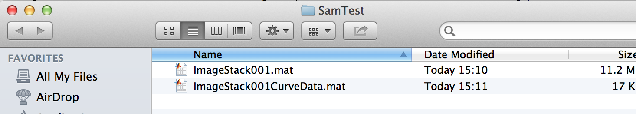

# Macintosh HD:Users:iasmam:Desktop:Screen Shot 2015-02-06 at 15.28.52.png

This are the two parameters directly in the code, that influence how the segmenation is done.

Rangeband= how much noise it is picking up  
spagtialband= how large a cell is (say 3 is the readious… if a cell is large, say always larger than 10, you might want 10, as the smallest cluster).

We can give a good default (as shown in the image).

The next step involves opening a guid

In the folder 1-ImageSementationFull there is a file called “CSG_v2.m”

Open in Matlab this file and start it. You should see:



Click on “New Experiment”

And enter the path, where you have been saving things, in all three boxes.



If you are a programmer, the 3 paths would make sense, or if you want to do some advanced output. Otherwise, if you have just been following this tutorial, you have to put 3 times the same path in.

If you were successful, you should see a dialog window, that should look like this: Important: it should have a number!



# Now to open a stack. You have to enter the experiment number and the number of the stack (see below)

# Macintosh HD:Users:iasmam:Desktop:Screen Shot 2015-02-07 at 14.42.13.png

# If everthing was working out. You should see your stack, with the outline of the cells.



This interface permits you to manually correct things. Say I would like to remove the small detected cell here, I would Shft+Click on it, and then save the data. Saving the data, means that I generate 3 new files for the stack. CewllArray001.mat

CellFrameData001.mat

Handledata_exp1.Stack.mat



# Options in the GUI

* You can delete cell shapes (also froma specific point)
* You can merge cells (even with merge point)
* There are instruction on the movie.

You can toggle off the short lived ones, and you can toggle of the small ones. Be careful as the two annul each other. Which is pretty annoying.

You can only load one stack at the time.  
You save them in your folder.

# Once all your files are done

Say, you have corrected all files, then you are ready for the next step: in Folder 1-ImageSegmantation Full, there is the file MakeBigStructs.m

Open it in Matlab and click on the “Run” Button.



There should be an explorer that opens, and you should enter as the directory, the experminet directory you have been using.



After selecting the folder, the program should create 2 new files in the folder, namely Bigcellarrayandindex.mat and BigCellDataStruct.mat (see below).



Now you are ready for the next processing step. You go to the Folder   
“2-ShapeManifoldEmbedding”

And open the script “RunShapeManifoldEmbedding.m” in Matlab. Click on the “Run” Button in Matlab, and the script should ask you for experiment folder (as before). Select the folder and when the script complets correctly, you should see the following dialog box.



Also, if the program run correctly, you should have the file “CellShapeData.mat” in your experiment folder.

Now you are ready to move to the steps in Folder

# 3 Extended Affinity Propagation

This step will cluster your sample according to the similarity of cell shapes. All files to complete this steps, will be in the folder   
“3-Extended_Affinity_Propagation”

The first preparatory stop consists in running the Affinity propagation. To do so, open the file “Run_Affinity_Propagation.m” in Matlab and click “Run”. The program should open a File Chooser for your Experiment Folder, the folder where you have saved the files of the previous steps. After selecting the folder, the program should start automatically. Progress of the program can be seen on the console. When the program finishes, you should see the following progress bars.



Once the program finishes successful, there should be nine new files in the folder, which should have the following names:



Inspecting the classification of shapes

Now we are ready to inspect the classification of shapes.

Open “unordered_list.m” and click on Run. Again select your experiment folder, and then the program should run through. You should get 2 figures.

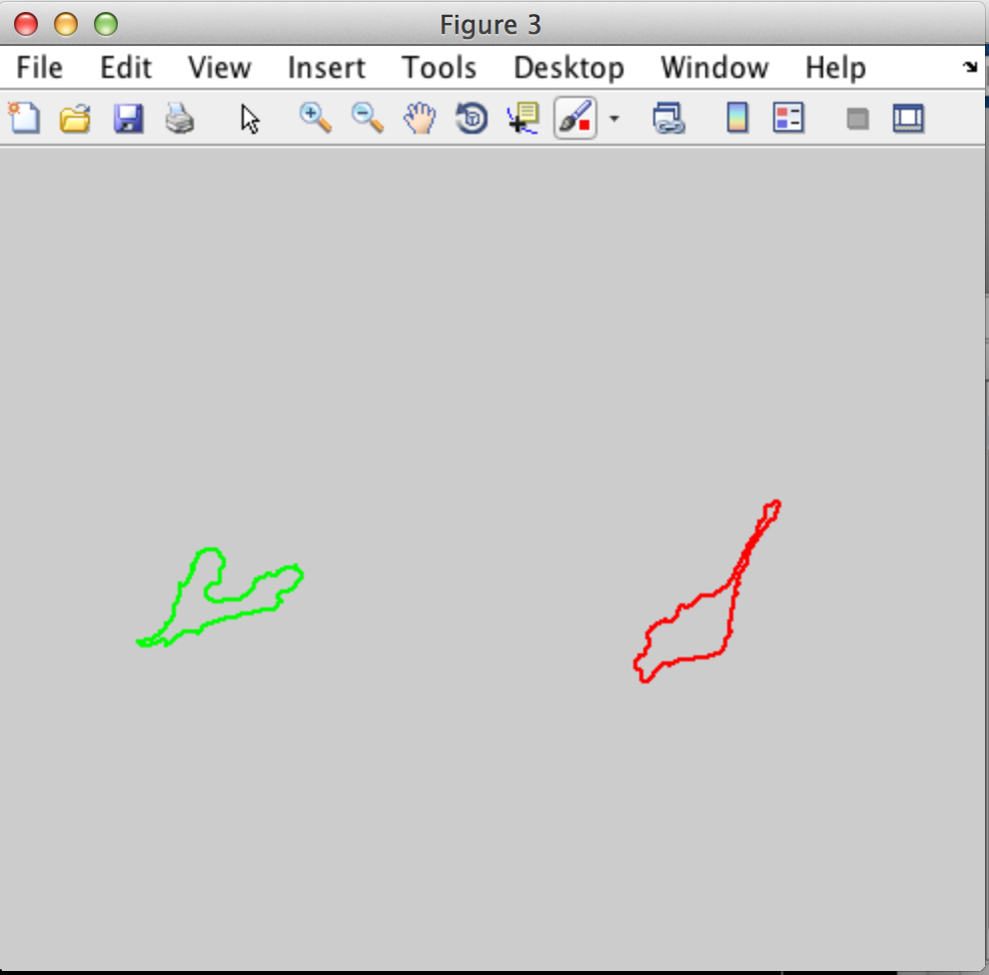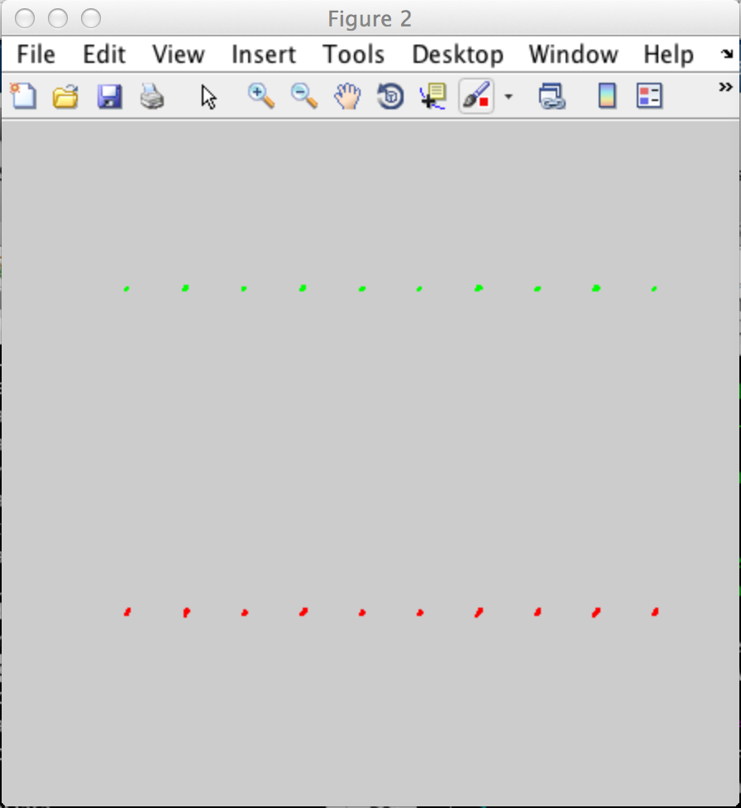

You can save vector images by clicking on File>Save As…

Dendogram of Shapes

Sometimes, the previous step might produce too many shape classes. You can force the classification of shapes to use less clusters. To make an informed choice, you should to have a look at the dendogram of shapes first.

To generate the dendogram of shapes, open “Run_Dendogram_of_Shapes( )” and click on “Run”.

The program should open a File Chooser and you should to select the Experiment folder. Upon successful completion, the program produces a dendogram, which is automatically saved as  
“Experiment Folder/Figures/ 3_Dendrogram_of_Shapes.fig

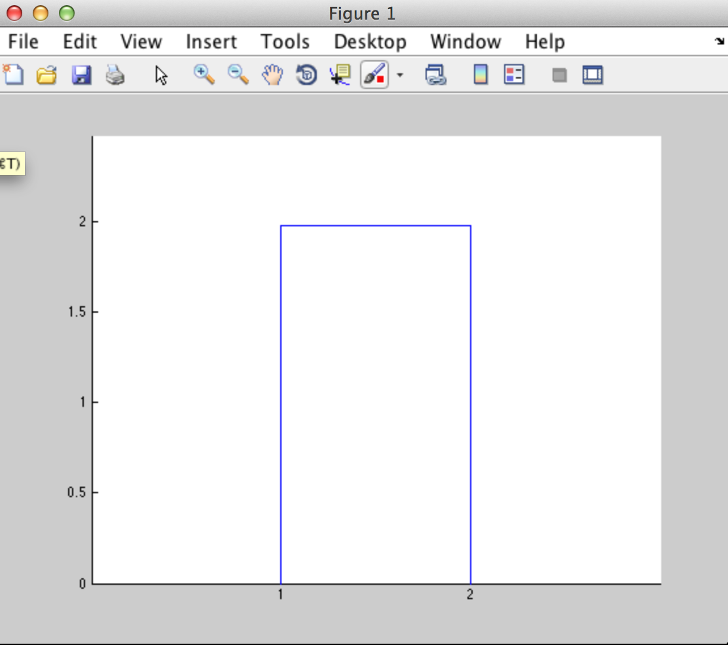

After running the dendogram, you should determine a number that is more appropriate for clustering your shapes. This number is important for the next step.

Then you are ready to run the next program: Open “Run_constrained_Clustering()” and click “Run” you should see the following graphical interface:

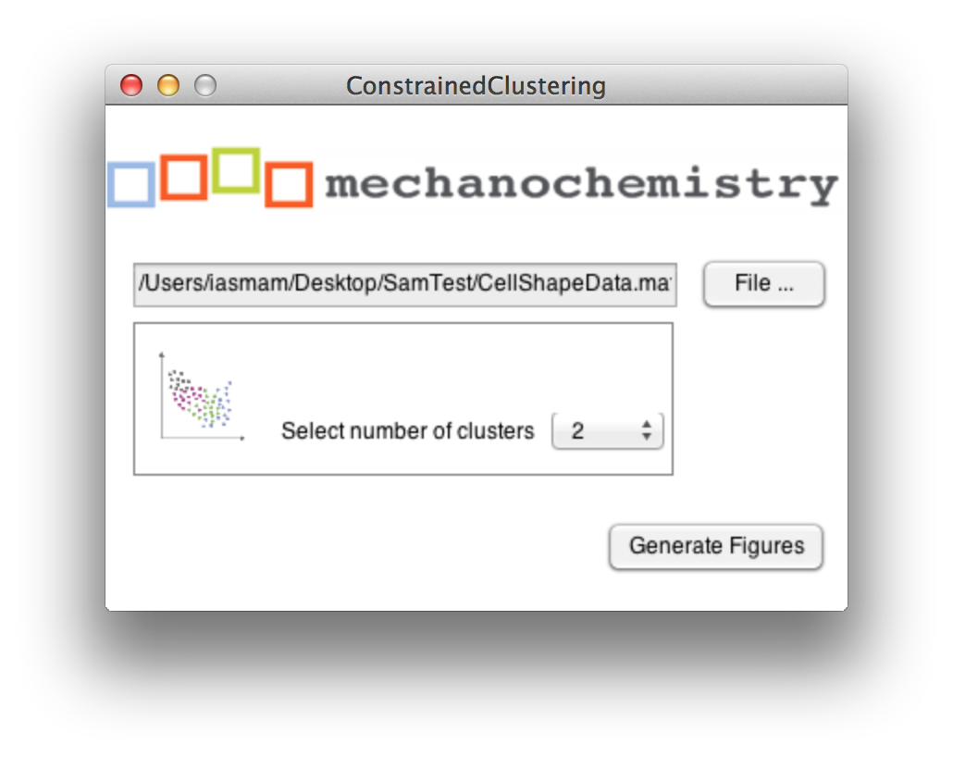

You need to click on the “File” button and select the file “CellShapeData.mat” in your experiment folder. Then you can select the number of classes you would like to limit you shape clustering. This number must be smaller than the maximum number of clusters you have in the dendogram. Ideallly your choice should be informed by the dendogram you generated before.

After selecting an appropriate number and clicking on “Generate Figure” you should get the following two figure:

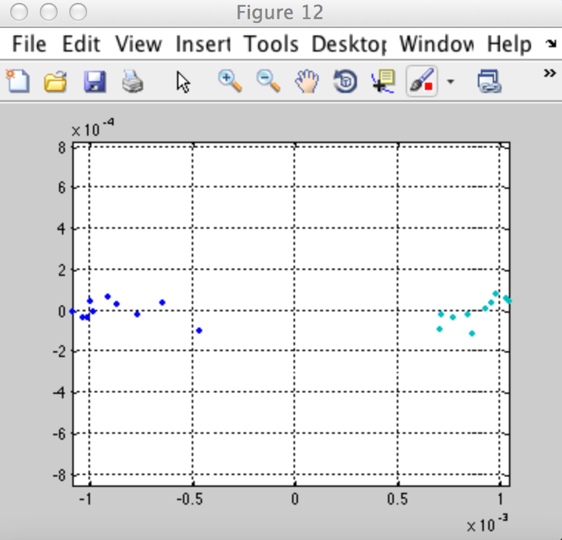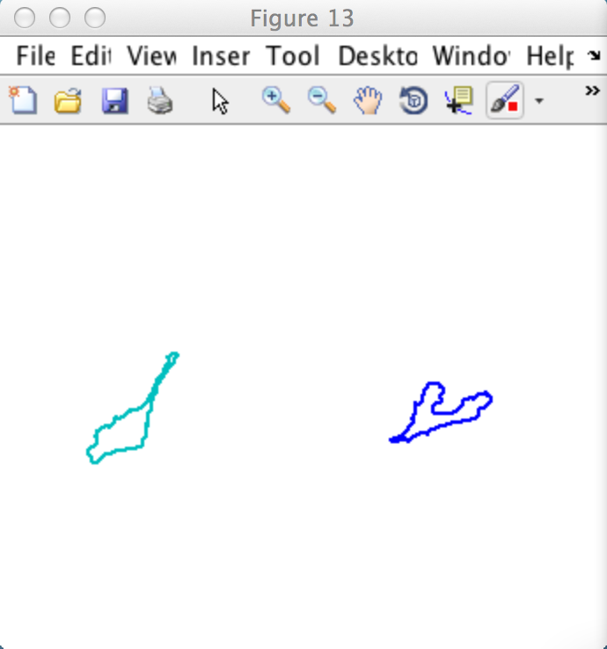

The figure on the left shows the coloured clusters in shape space. The figure on the right shows a typical representative for this cluster. These two figures are automatically saved in the Experiment Folder/Figure/ with the following in the following files:

* 3_Avg_Shape_for_Clusters.fig
* 3_Coloured_Shape_in_ShapeSpace.fig

# 4 Shape Slicer

To run the shape slicer, you need to go to folder “4-Shape_Averaging”, open the file “Run_SpaceSlicer”, and click on the “Run” button in Matlab. You should then see the following graphical interface. You click on the button “File” to select the Matlab file “CellShapeData.mat” from your experiment Folder. Then you click on the “Generate Figure” to run the program.

The graphical interface allows you to configure the slices on the x and y axis, and whether you would like to force the two aces to be on the same scale.

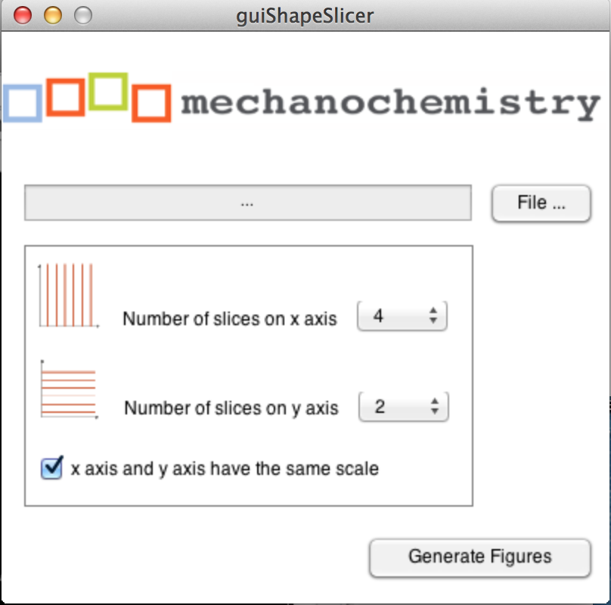

Figure Shape Slicer GUI: Select CellShapeData.mat and configure the slices for the x and y axis.

When the program runs successfully, you should receive four different figures as output. One of those figures should look somewhat similar to the figure below. If you click on the figure under File 🡪 Save As… you can save the figure in vector format and modify with any graphic program.

Note: The program automatically saves in your “Experiment Folder🡪 Figures” all the figures that are generated. However, they are overwritten each time you generate new figures. All four figures begin with a name “4_ShapeSlicer_***” so that you know they are from your fourth step in the process.



Figure Sliced Shape Space: blue figures indicate average space in slices along the x-axis, green figures indicate average shape in slices along the y-axis.

However, the program also produces the single parts of the programs individually, e.g. the average figures along the axis as well as only the content, permitting maximum flexibility in graph creation.



Figure : Partial output: left average figure along the x-axis, middle average figure along the y-axis, and shape in the sliced grid.

# 5 Out of sample extension

First, For out of sample extension. I need to train new addition to the sample. For this tutorial, I use the same movie but frame 11 & 12.

* RunMeFirst with this line: RunMeFirst(1, 11,12, '/Users/iasmam/Desktop/SamJ_Code_and_Data/DemoData/GLA6_exp3_220713_untreated01_114_R3D.dv','/Users/iasmam/Desktop/SamTest/OOSse' )
* Correct data
* MakeStructre

And now I am ready start.

LP_OoSE_train(CellShapeData, '/Users/iasmam/Desktop/SamTest/OOSse' )

CellShape Data comes from CellShapeData.mat from the big training set (not from the small set!)

After this, we have generated in OOse, the file: LP_trained.mat



The structure insiside LP has a Nx5 matrix. N is the number of frames we analised.

Next step, we run LP_OoSE_run;

* Where CellShapeData comes from the big set
* BigCellArray comes from the new possible small set.

LP_OoSE_run(CellShapeData, BigCellArray, '/Users/iasmam/Desktop/SamTest/OOSse/LP_trained.mat', '/Users/iasmam/Desktop/SamTest/OOSse/' )

Your console look like this.

And you should have this new files in your folder

* Dist_mat.mat
* OoSE_embedding.mat

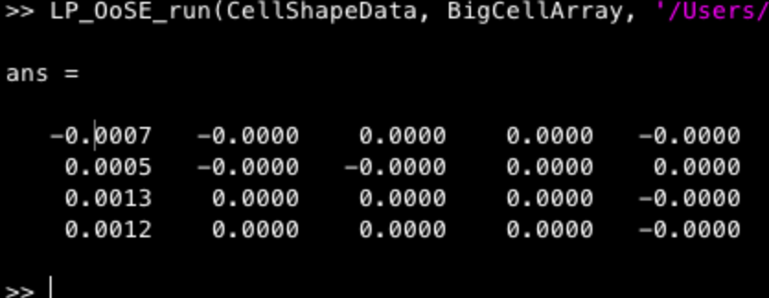

Now you are ready to the 3rst step:

To get it to run, enter the following:

OoSE_bargraphs(2, CellShapeData, '/Users/iasmam/Desktop/SamTest/', '/Users/iasmam/Desktop/SamTest/OOSse')

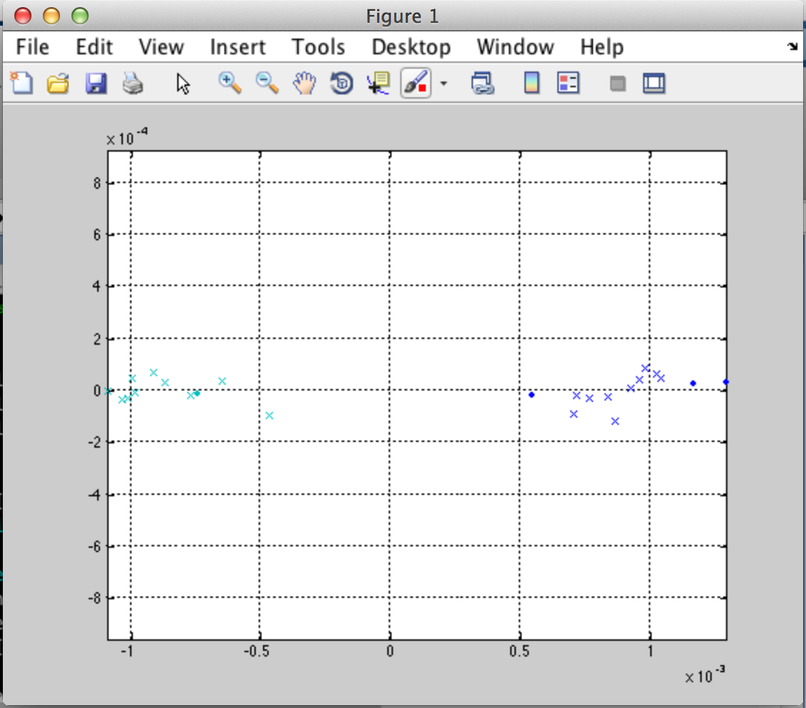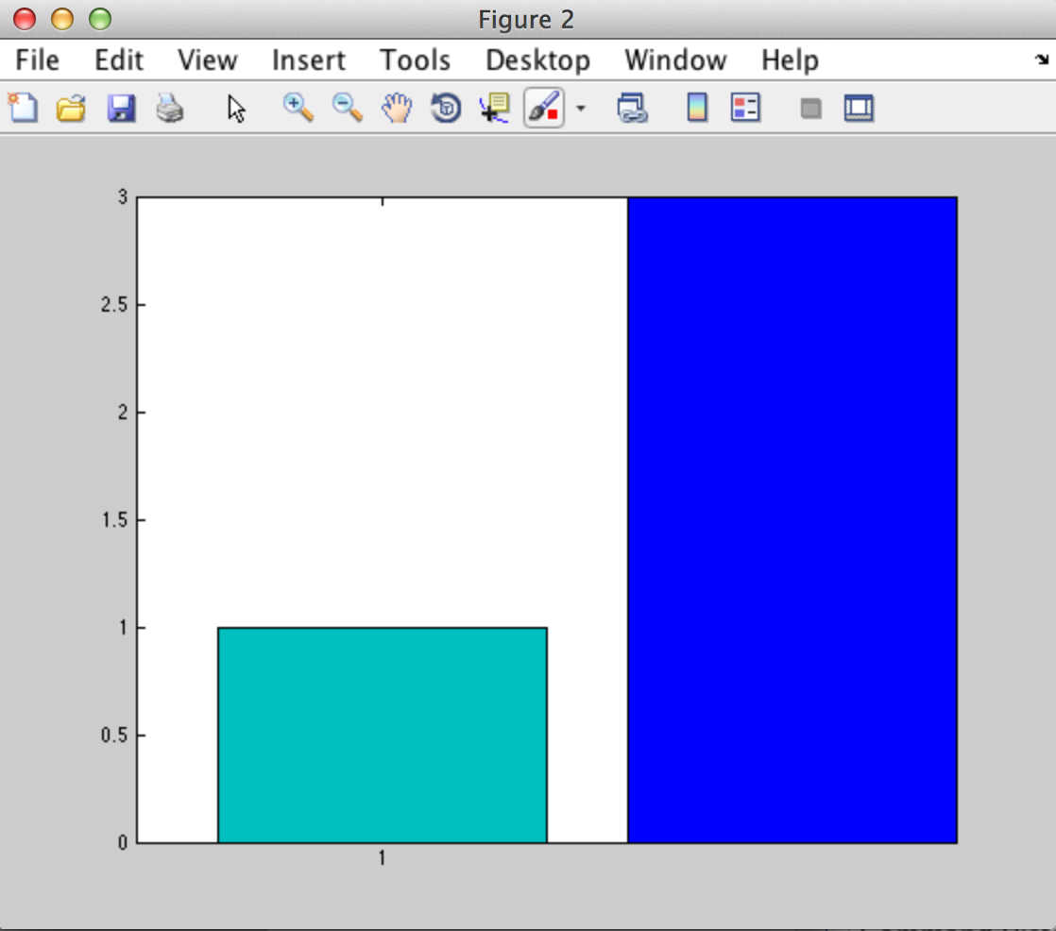

Now, we see with the crosses the two clusters of shape we have had from the big set. However, the two dots (two green and two blue) are the points that came from the out of sample addition. 3 of the new ones are blues, while one is a greenish one.

# 6 Out of sample extension

Run first MorpProps as for example with

Morph_Props(BigCellArray, '/Users/iasmam/Desktop/SamTest')

BigCellArray comes from opening “Bigcellarrayandindex.mat” from the big training sample.

This process can be close. After running this process, we have a new file in the folder.



Now we are ready to produce a graph with the following command

Prop_display(CellShapeData, morphframe, 'Area')

Where

* CellShapeData comes from the big set
* Morphframe from previous operation
* ‘Area’ is one of the possibilities we can select and get

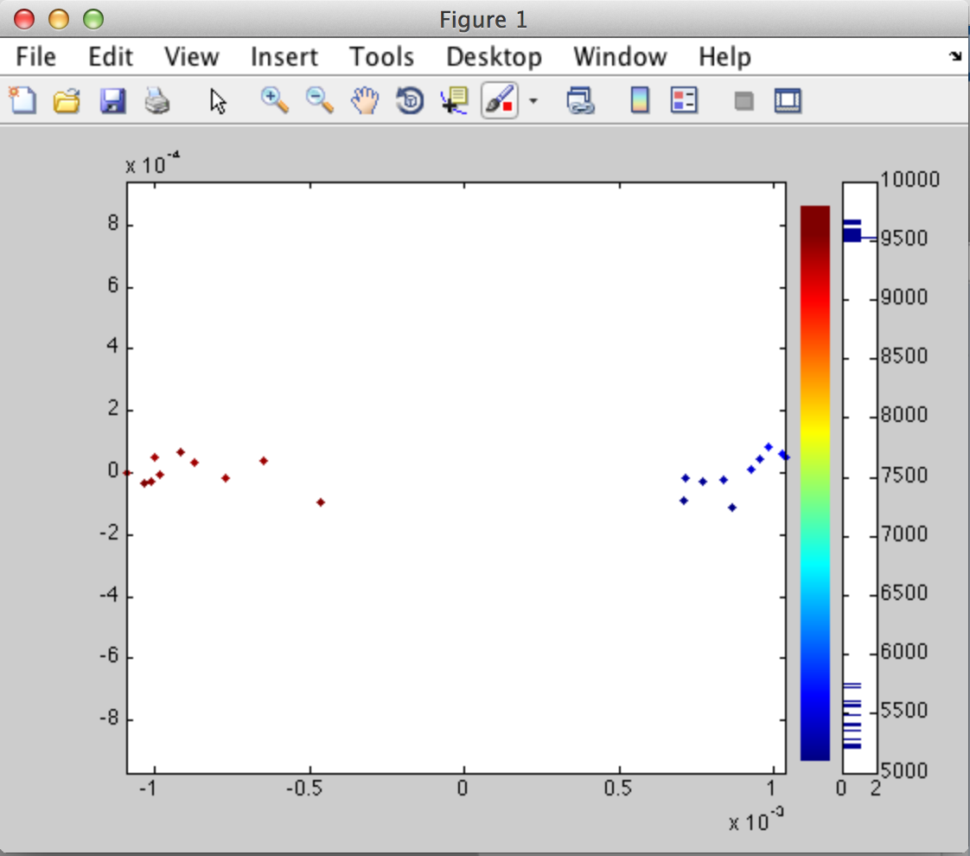

# Step 7 Shape Space Dynamic

To start it, you type for your example this:

ShapeSpaceDynamics(cell_indices, CellShapeData, '/Users/iasmam/Desktop/SamTest')

* cell_indices is from the big sample from the file “Bigcellarrayandindex.mat”
* CellShapeData comes from the “CellShapeData.” Also from the big data set.

After this operation we have a new file, DynamicData.mat



in the structure we get we have the following fields:

* Track (is track per cell)
* Speed (is the speed of the cell)
* Average speed is the average speed per tack
* Angles is the angle per cell
* Av_displacement_direction : average displacement direction the cell does in its track.

If we have N cells segmented, we should have N structures in this array.

So the first plot we can generate is with this line

Local_direction_rose_plots(DynamicData)

We can influence in how many slices we want to cut the data. “Nbins=[10 6];” in the source code is the important line.

We get than this graph: This shows the local directions in the grids.

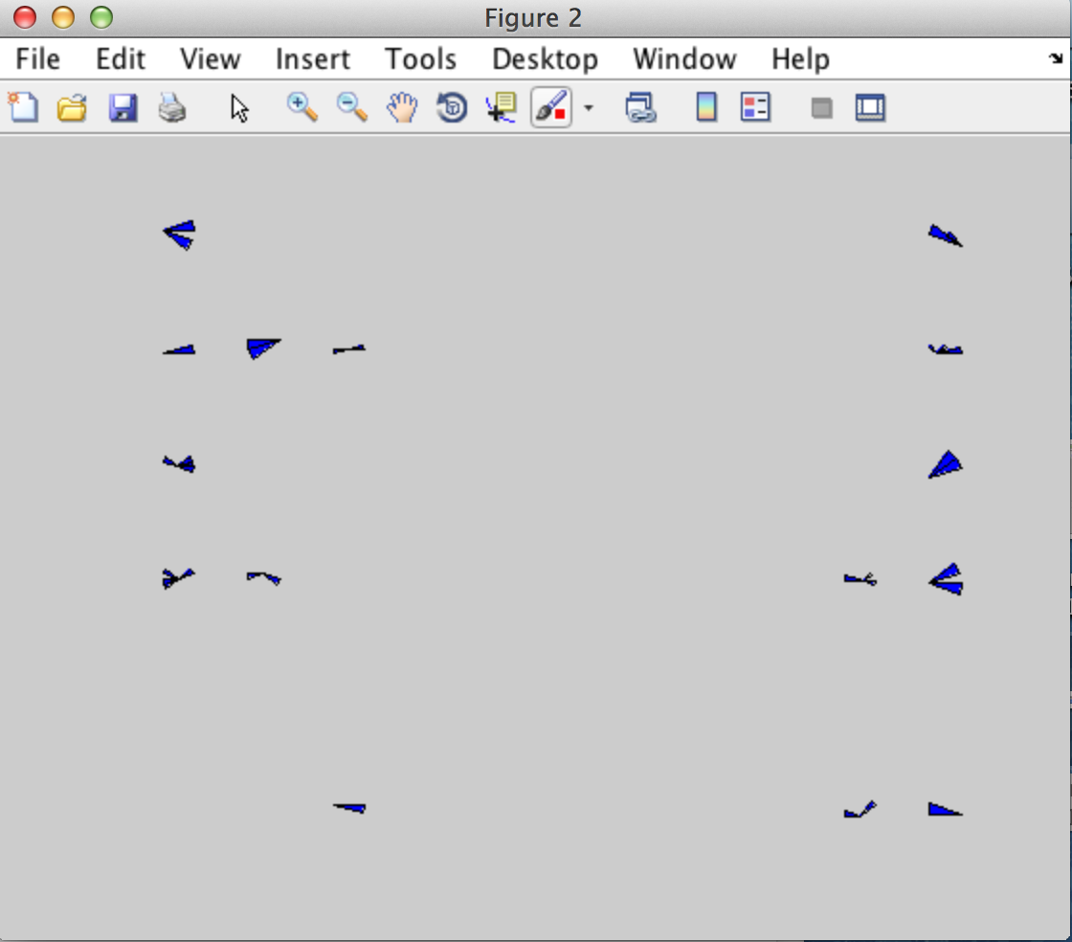

The other figure we can create is by typing this:

Exemplar_direction_rose_plots(DynamicData, CellShapeData, 2, '/Users/iasmam/Desktop/SamTest')

* Dynamic Data comes from Folder 7 first step.
* CellShapeData (big sample)
* 2 is the number of cluster, we have determined this in step 3, by looking at the dendogram.
* Foldername, to get the AffinityDatasample files, in detail, they are
  + APclusterOutput.mat
  + Wish_list.mat
  + Linkagemat.mat

The graph we get is the on in the bottom.

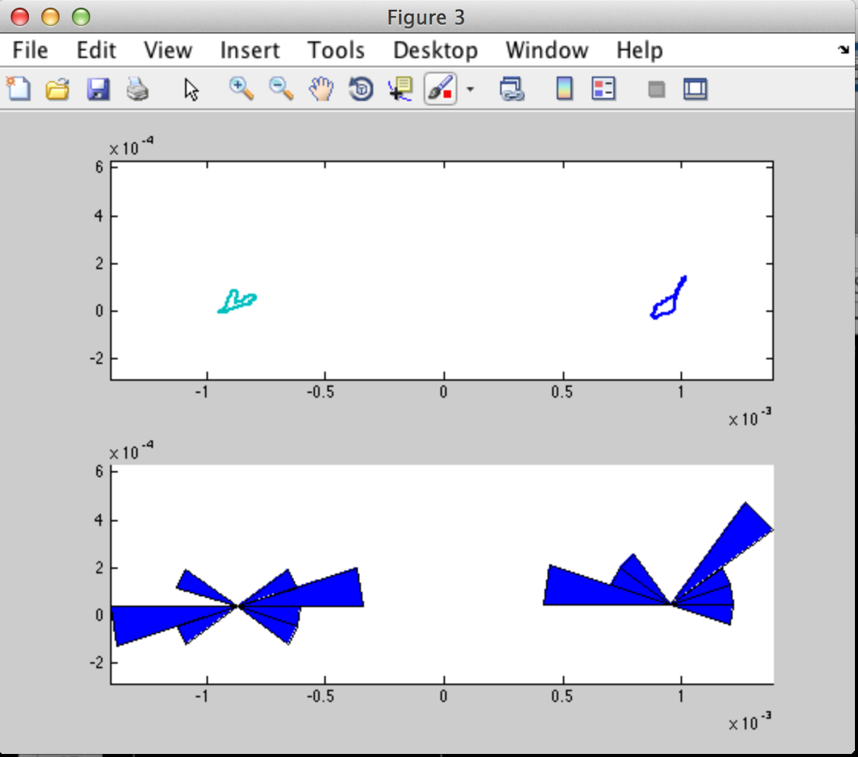

Things to explain at the beginning.

* The experiment folder.
* Run a program in matlab
* Console in matlab.
* What to do if program does not finish as expected.
  + Do you use a matlab version that we have tested (see list)
  + Do you have followed the step as before and used the guidelines in where to place your files
  + Ask a technical person in your team, ideally, someone who is a matlab programmer
  + Ask the authors.
  + How to save figures in matlab in any format you like.
  + File Chooser